STUDIES IN REVELATION

With

Dr. Joe Arthur
&
Harvest Staff

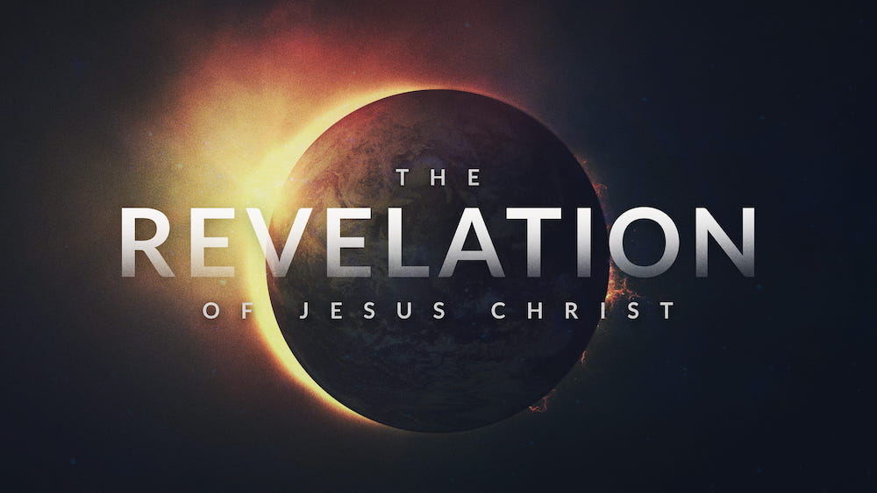

REV. 15 – 16 SEVEN VIALS

Outline of Revelation:

Ch. 1 - Revelation of Christ
Ch. 2 & 3 - Rebuke and admonition to the churches
Ch. 4 - Rapture of the church
Ch. 5 - 16 - Reckoning wrath of God upon the nations
Ch. 17 - 18 - Ravaging of Babylon.
Ch. 19 - Reunion at the marriage supper of the lamb.
Ch. 20 - Rebellion of Satan and his torment forever.
Ch. 21 - 22 - Regal glory of heaven and all of its splendor.

CONSIDER THE MANY JUDGMENTS IN THE SCRIPTURES!

GEN. 6 - GLOBAL JUDMENT ( FLOOD )
EXODUS 7 – 11 - DOMESTIC JUDMENT ( EGYPT )
MATT. 27, MARK 15, LUKE 23, JOHN 19 – CROSS !!!
PERSONAL JUDMENT - ( JESUS )
* THIS WAS THE MOST VILE JUDMENT EVER !

NOW, WE SEE THE WRATH OF GOD POURED OUT UPON THE NATIONS.

SEVEN SEALS - ( CONQUEST, WAR, FAMINE, DEATH, RELIGIOUS PERSECUTION, CATASTROPHIC EVENTS, ( EARTHQUAKES, SUN DARKENED, MOON TO BLOOD, STARS FALLING )
SEVEN TRUMPETS - ONE – THIRD OF THE EARTH, ALL OVER THE GLOBE IS JUDGED BY THE HAND OF GOD. ( HAIL & FIRE, GREAT FIERY MOUNTAIN CAST INTO SEA WHICH BECOMES BLOOD, STAR FROM HEAVEN – WORMWOOD UPON RIVERS, DARKNESS, DEMONIC LOSUST, GREAT ARMY SLAYING ONE – THIRD OF MANKIND. )

LOOK AT THE FINAL VIAL JUDMENTS :

- THE JUDGMENT COMMANDED – V. 1

THE VOICE OF GOD SPEAKING

- THE SEQUENCE – YOUR WAY
- THE SWIFTNESS - FINAL WRATH

- THE JUDGMENT COMMENCED – V. 2-9

A. UNEXPECTED CANCER OF SORES – V.2, 11

UPON THOSE WITH THE MARK OF BEAST
A REPRODUCTION OF THE SIXTH PLAGUE UPON EGYPT - EXODUS 9:8-12 - BOILS
EXO 9:11 - 12 AND THE LORD HARDENED THE HEART OF PHARAOH, AND HE HEARKENED NOT UNTO THEM;

NOTICE…. THE SAME RESULT IN EXODUS CHAPTER 9. OCCURS HERE IN THE TRIBULATION - V. 11

- UNEXPLAINED CONTAMINATION OF SEAS –

- UNEXAGGERATED CORRUPTION OF THE STREAMS - V. 4-7
- THE REALITY OF JUDGMENT – V. 4

- THE RIGHTEOUSNESS OF - V. 5-6

- THE RESPONSE TO - V. 7

FROM THE ALTAR OF CONSUMING JUDGMENT !!

THIS IS WHERE THE SOULS OF THOSE WHO WERE SLAIN FOR THEIR FAITH, AND NOW THE ALTAR CRIES OUT WITH A RESOUNDING “ AMEN ! “

